Join us for a Kindergarten
BACK TO SCHOOL…BASH
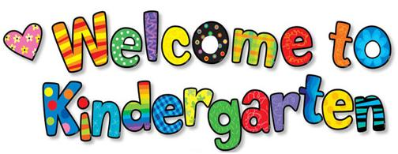
Sept. 28 4:15-7:30pm
Woodland Parents and Kindergarteners of class of 2028 are invited to a meet and greet mixer with chips, dips, and soda. Kindergarten teachers will be present and this night only Roasted Pear has offered our kindergarten families 1 free kids meal with each adult entrée purchased. So please come meet, mingle, find out about volunteer opportunities, chat, & let someone else cook dinner…It will be a Monday!!
For more info: 480-540-0477
To be held at and kindly sponsored by~

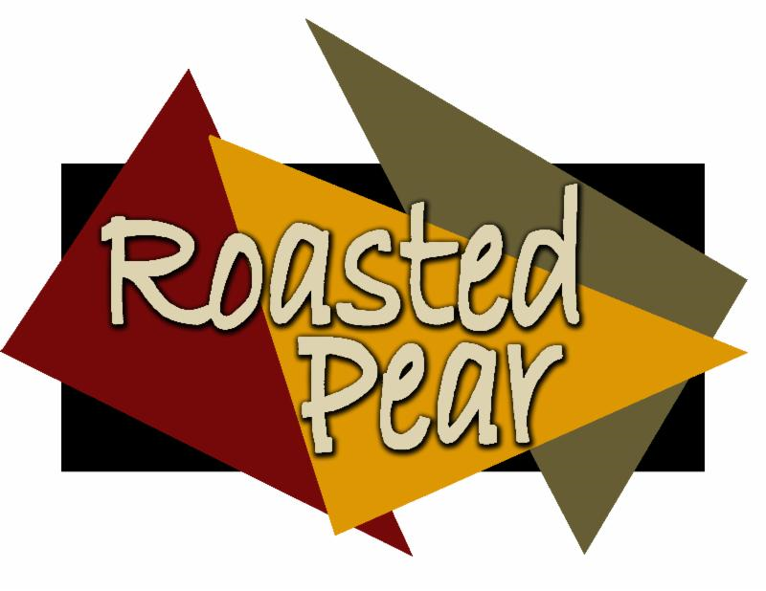
For each adult entrée purchased; receive one child’s meal free
(Woodland Kindergarten Mixer)
Valid 9-28-15
9690 Colorado Lane (by cub foods @ 610)

